Educational Epiphany ™
Districtwide PLC Protocol for Mathematics
Teacher/Teacher Team: K. West, E. Adjei, J. Domfeh
Grade/Course: Algebra 1
Date: Week of September 25, 2023

# | Planning Question | Teacher/Teacher Team Response
Algebra 1 Coherence Tool: Access the foundational standards to make connections to previously taught skills during the lesson introduction.
1 | Which state standard is your lesson progression addressing? | Lesson 2-1: Slope Intercept Form | Lesson 2-2: Point-Slope Form | BENCHMARK TESTING
 |  | A1.F.LE.A.2 Construct linear and exponential functions, including arithmetic and geometric sequences, given a graph, a table, a description of a relationship, or input-output pairs. «  A1.S.ID.C.5 Interpret the rate of change and the constant term of a linear model in the context of the data. «  Foundational Standards: 8.F.B.4, 8.SP.A.3 | A1.F.LE.A.2 Construct linear and exponential functions, including arithmetic and geometric sequences, given a graph, a table, a description of a relationship, or input-output pairs. «  A1.S.ID.C.5 Interpret the rate of change and the constant term of a linear model in the context of the data. «  Foundational Standards: 8.F.B.4, 8.SP.A.3 | Provide two days this week for students to complete District CFA.
2 | What mathematical concepts are embedded in the state standard? | - Construct a linear function given a graph.  - Construct a linear function given a table of values.  - Construct a linear function given a description of a simple real-world relationship.  - Construct a linear function given a set of input-output pairs (ordered pairs).  - Interpret the rate of change of a linear model in the context of the data.  - Interpret the constant term of a linear model in the context of the data. | - Construct a linear function given a graph.  - Construct a linear function given a table of values.  - Construct a linear function given a description of a simple real-world relationship.  - Construct a linear function given a set of input-output pairs (ordered pairs).  - Interpret the rate of change of a linear model in the context of the data.  - Interpret the constant term of a linear model in the context of the data.
3 | What teacher knowledge, reminders, and misconceptions are assumed in the standard? | Knowledge:  - As A2.F.LE.A.2 is a modeling standard, real-world examples should be provided, and students should be required to explain how the function models the context.  - It is important that students build an understanding that fitting a line to data in a scatter plot reveals possible relationships between two quantities and provides a tool for analyzing the data. Therefore, students should investigate models with the intention of interpreting them in the context of the data.  - Instruction should expose students to multiple contextual linear models and ask them to capture key elements of the relationship between the two variables and explain what the model reveals about the relationship. Specifically, students should be interpreting key features of linear models such as slope and y-intercept.  - Instruction should focus on slope as the rate of change of the function, identifying for every increase of one by the independent variable (i.e., x), the dependent variable (i.e., y) increases or decreases by the given slope.  - Discussion and questioning should be focused on interpretation of the y-intercept as the value of the dependent variable when the independent variable is zero and that when the independent variable is a unit of time, the y-intercept can be interpreted as the initial value of the dependent variable.  - Students should be expected to interpret values such as f(12) or f(0), or solve equations like f(t) = 0. In the real world, there are instances when the initial value may not be the y-intercept. Providing students examples of such situations can elicit strong discussions around why the y-intercept is not useful for interpretation in that context.  Reminders:  - This is a good opportunity to relate input and output values with independent and dependent variables.  - Students were introduced to this concept in grade 8 and continue to investigate and interpret linear models in context in high school.  Misconceptions:  - Have students focus on the interpretation of slope as a unite rate can help reduce confusion and can provide a conceptual foundation for interpreting the slope within the context of a situation. | Knowledge:  - As A2.F.LE.A.2 is a modeling standard, real-world examples should be provided, and students should be required to explain how the function models the context.  - It is important that students build an understanding that fitting a line to data in a scatter plot reveals possible relationships between two quantities and provides a tool for analyzing the data. Therefore, students should investigate models with the intention of interpreting them in the context of the data.  - Instruction should expose students to multiple contextual linear models and ask them to capture key elements of the relationship between the two variables and explain what the model reveals about the relationship. Specifically, students should be interpreting key features of linear models such as slope and y-intercept.  - Instruction should focus on slope as the rate of change of the function, identifying for every increase of one by the independent variable (i.e., x), the dependent variable (i.e., y) increases or decreases by the given slope.  - Discussion and questioning should be focused on interpretation of the y-intercept as the value of the dependent variable when the independent variable is zero and that when the independent variable is a unit of time, the y-intercept can be interpreted as the initial value of the dependent variable.  - Students should be expected to interpret values such as f(12) or f(0), or solve equations like f(t) = 0. In the real world, there are instances when the initial value may not be the y-intercept. Providing students examples of such situations can elicit strong discussions around why the y-intercept is not useful for interpretation in that context.  Reminders:  - This is a good opportunity to relate input and output values with independent and dependent variables.  - Students were introduced to this concept in grade 8 and continue to investigate and interpret linear models in context in high school.  Misconceptions:  - Have students focus on the interpretation of slope as a unite rate can help reduce confusion and can provide a conceptual foundation for interpreting the slope within the context of a situation.
4 | What objective(s) must be taught? In what order? Why? | PBO:  - SWBAT use the slope-intercept form IOT write and graph linear equations  Lesson objective(s):  - Write linear equations in two variables using slope-intercept form to represent the relationship between two quantities.  - Interpret the slope and the intercept of a linear model. | PBO:  - SWBAT analyze a graph, table, description of a relationship, or input-output pairs IOT construct linear and exponential functions, including arithmetic and geometric sequences.  - SWBAT analyze data IOT to interpret the rate of change of a linear model in context.  - SWBAT analyze data IOT to interpret the rate of change of a linear model in context.  Lesson objective(s):  - Write and graph linear equations in point-slope form.  - Analyze different forms of a line to interpret the slope and y-intercept of a linear model in the context of data.
5 | What academic language must be taught before the teacher models for students? How will the academic language be taught and assessed? | Academic Language:  - ​Analyze – examine in detail  - Graph – a diagram showing the relation between variable quantities  - Construct – to make or create  - Linear Function – a function whose graph is a line and is represented by a linear equation  - Rate of Change – slope; the ratio of the vertical change to the corresponding horizontal change in the coordinate plane  - Linear – related to or forming a line  - Model – representation of a concept; to draw, show or explain mathematically  - Context – the surrounding or background information used to determine, specify, or clarify the meaning of an event or other occurrence  - Constant – a fixed value or quantity that does not change its value  Instructional Practice 2:  Strategies used to teach unfamiliar words will include:  - 30 – 30 – 30 (common math-related word parts in the text, problem or objective)  - Point of Use Annotation of Performance-Based Objective  - Universal Language of Literacy  - Word-and-Definition Word Walls  - Word Parts  - Context Clues  - Point of Use Annotation of the Texts (In Real Time) | Academic Language:  - ​Analyze – examine in detail  - Graph – a diagram showing the relation between variable quantities  - Table – numbers or quantities arranged in rows and columns  - Description – to represent or give an account in words  - Input – the domain of a function or relation; a value of an independent variable  - Output – the range of a function or relation  - Construct – to make or create  - Linear Function – a function whose graph is a line and is represented by a linear equation  - Exponential Function – any function of the form $f\left(x\right)={ab}^{x}$where $a$ and $b$ are constants and $a≠0$, $b>0$, and $b≠1$  - Arithmetic Sequence – a number sequence formed by adding a fixed number to each previous term to find the next term  - Geometric Sequence – a number sequence formed by multiplying a term in a sequence by a fixed number r to find the next term  - Analyze – discover or reveal something through detailed examination  - Data – a collection of information or facts  - Interpret – explain the meaning of (information, words, action)  - Rate of Change – slope; the ratio of the vertical change to the corresponding horizontal change in the coordinate plane  - Linear – related to or forming a line  - Model – representation of a concept; to draw, show or explain mathematically  - Context – the surrounding or background information used to determine, specify, or clarify the meaning of an event or other occurrence  - Constant – a fixed value or quantity that does not change its value  Instructional Practice 2:  Strategies used to teach unfamiliar words will include:  - 30 – 30 – 30 (common math-related word parts in the text, problem or objective)  - Point of Use Annotation of Performance-Based Objective  - Universal Language of Literacy  - Word-and-Definition Word Walls  - Word Parts  - Context Clues  - Point of Use Annotation of the Texts (In Real Time)
6 | What practice problems are you planning to use for the Explore, Understand & Apply, Practice & Problem Solving, and Assess & Differentiate portions of the lesson? What did you learn from working the problems in advance of using them in class with students? | Technology Integration Suggestions using Savvas Realize Platform  - Step 1: Explore  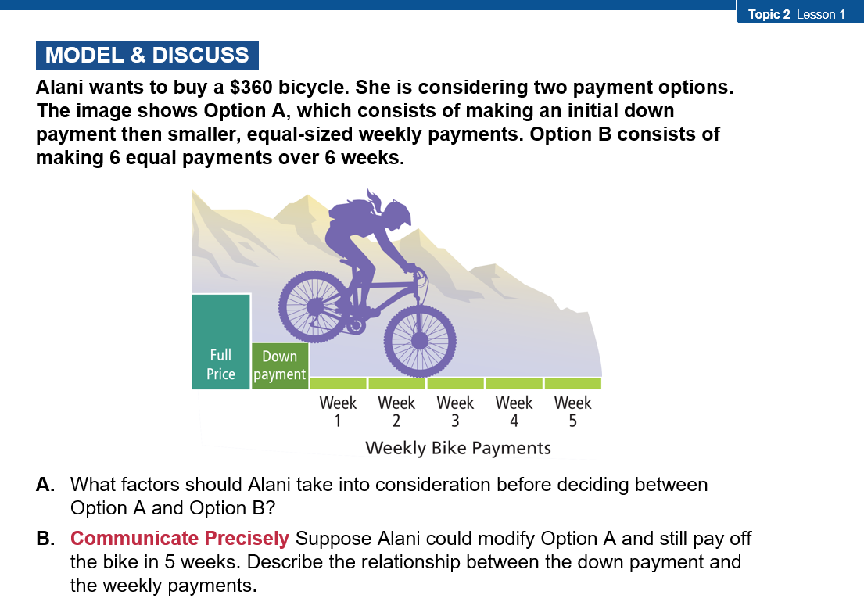  - Step 2: Understand and Apply: Examples  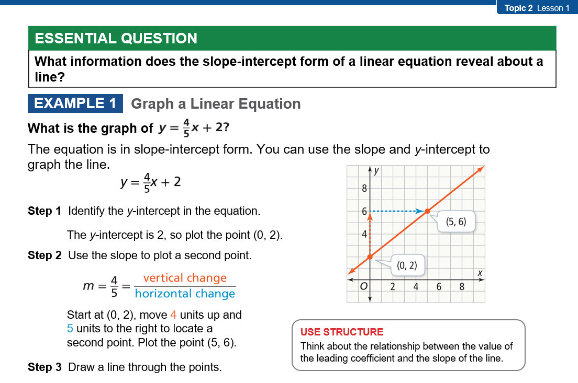  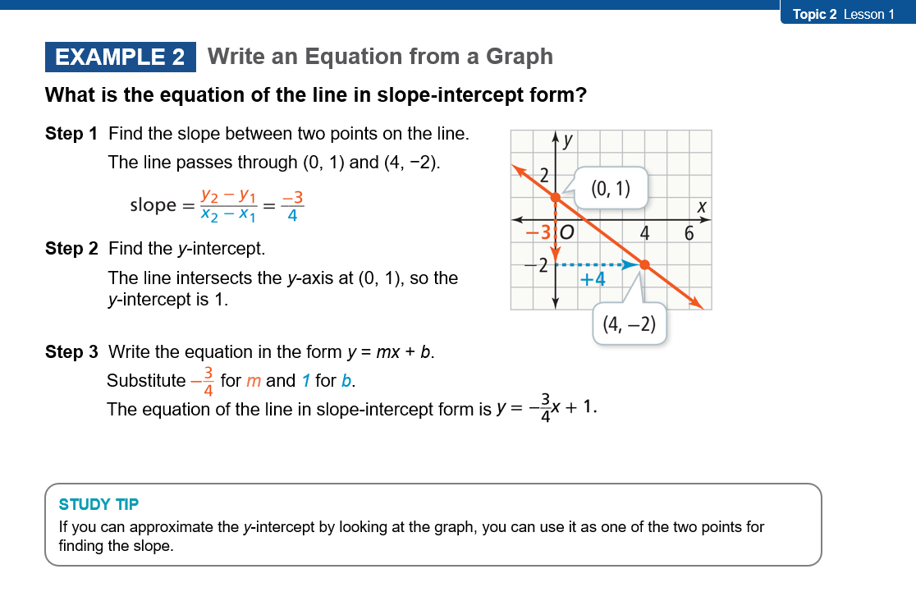  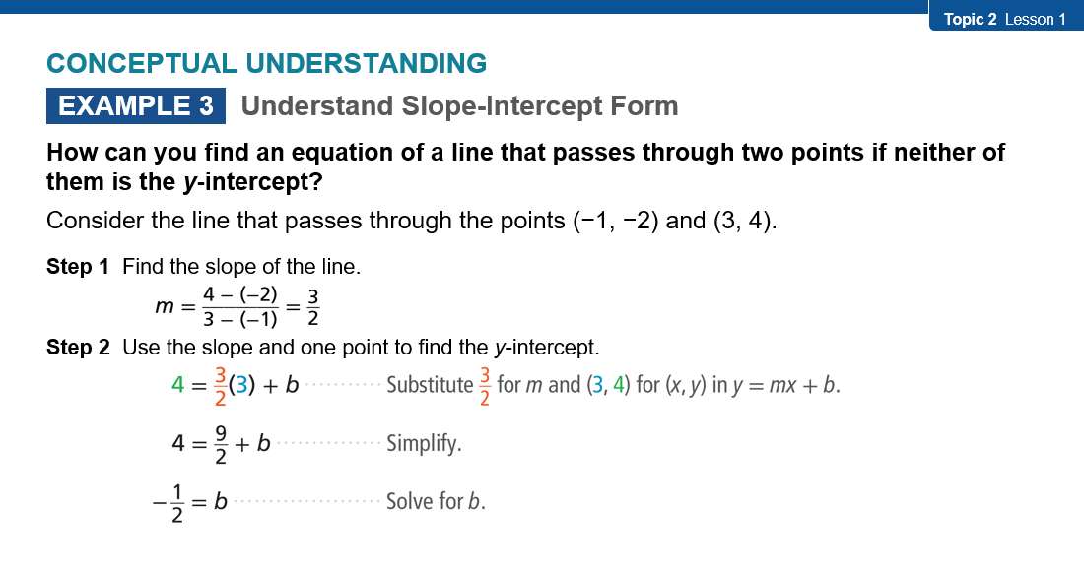  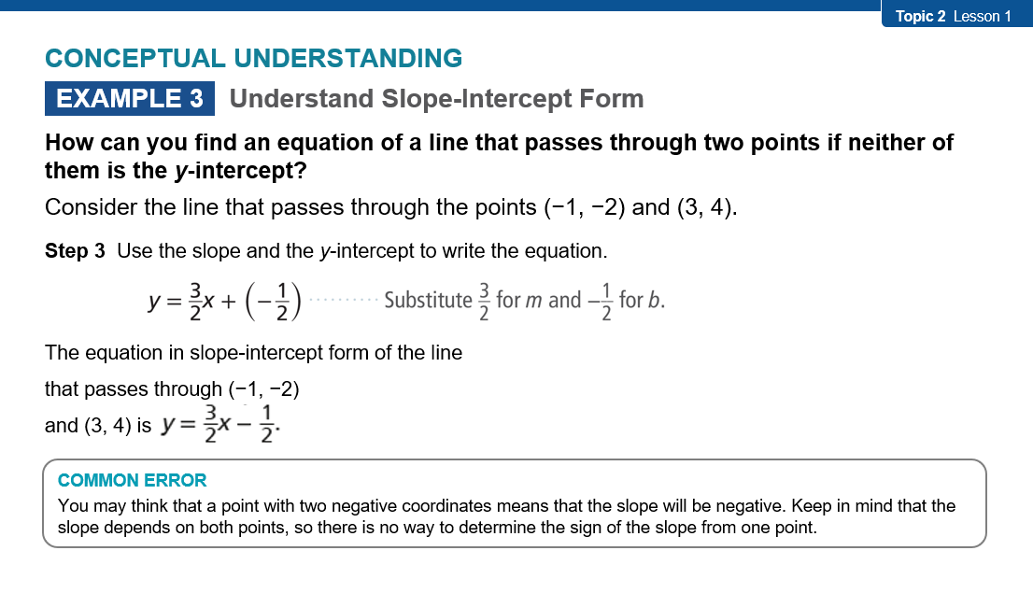  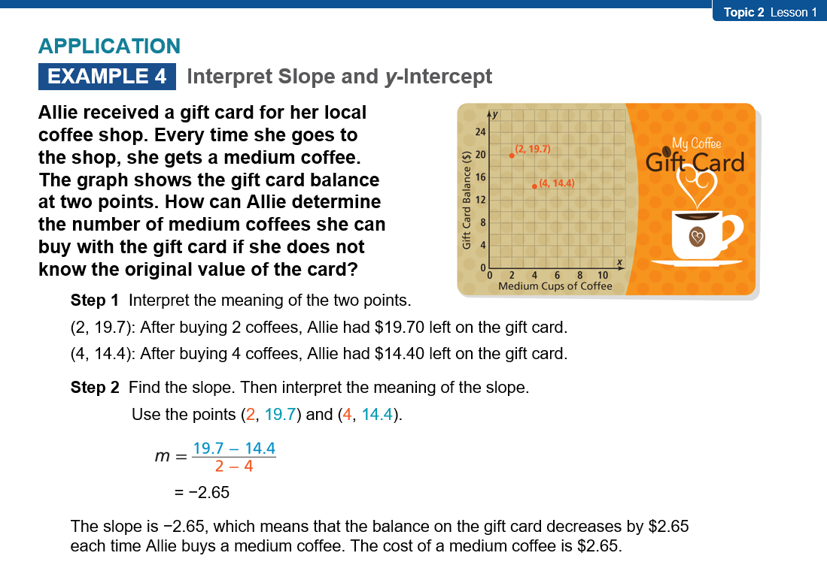  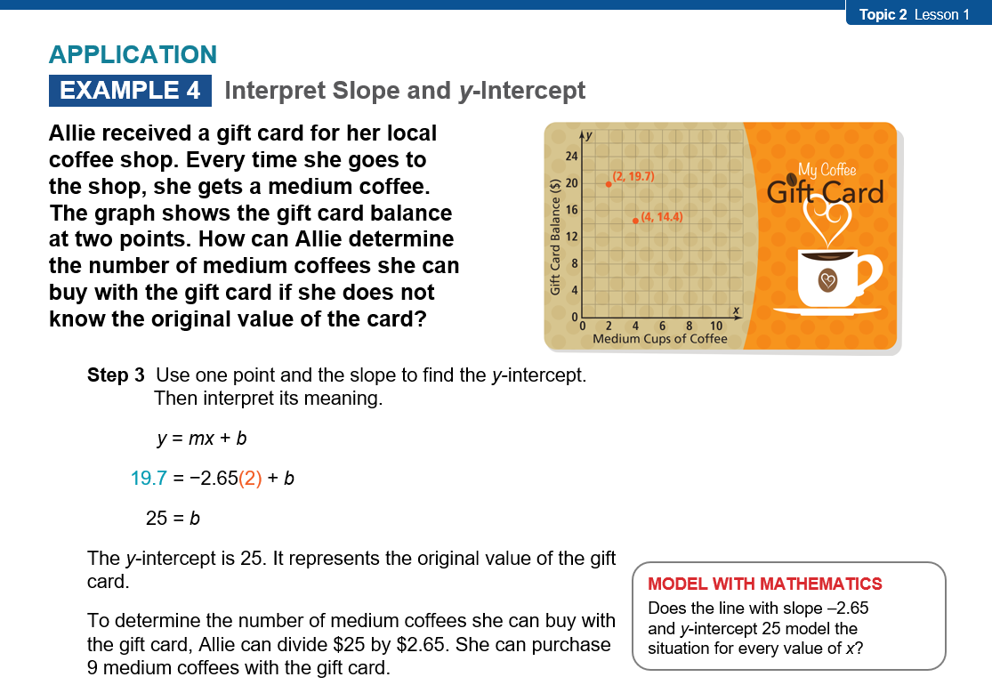  - Step 3: Practice & Problem Solving: MathXL and Adaptive Practice  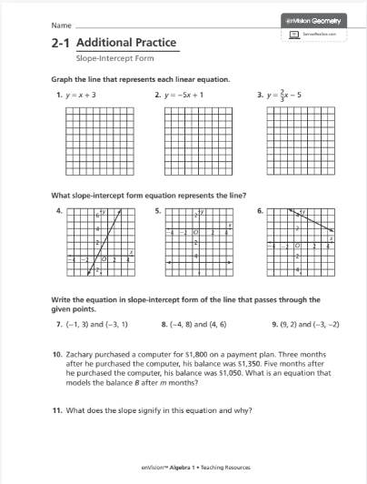  - Step 4: Assess & Differentiate: Lesson Quiz, MathXL, Resource  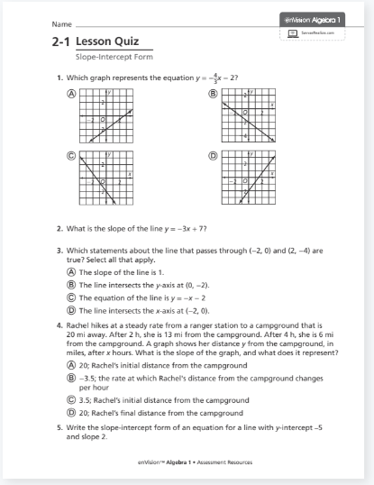  - PDFs, and Virtual Nerd Video(s)  - Tennessee Standards Practice Workbook  For technology integration resources and suggestions, please click here. | Technology Integration Suggestions using Savvas Realize Platform  - Step 1: Explore  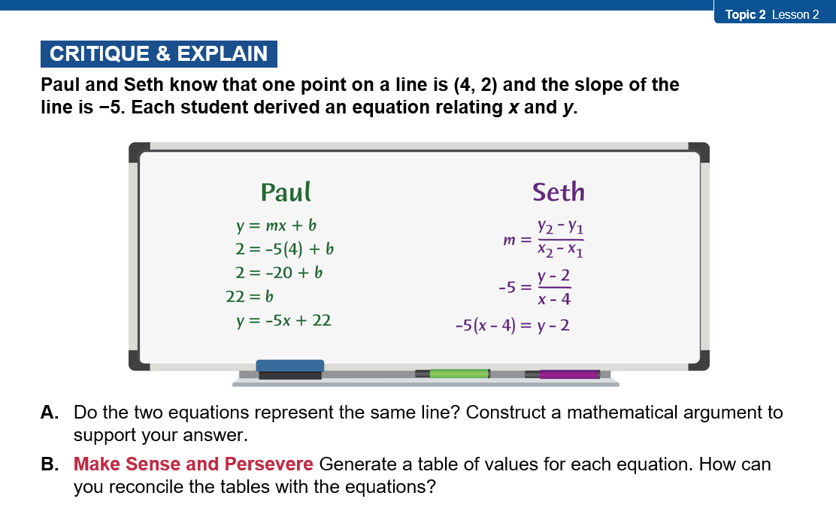  - Step 2: Understand and Apply: Examples  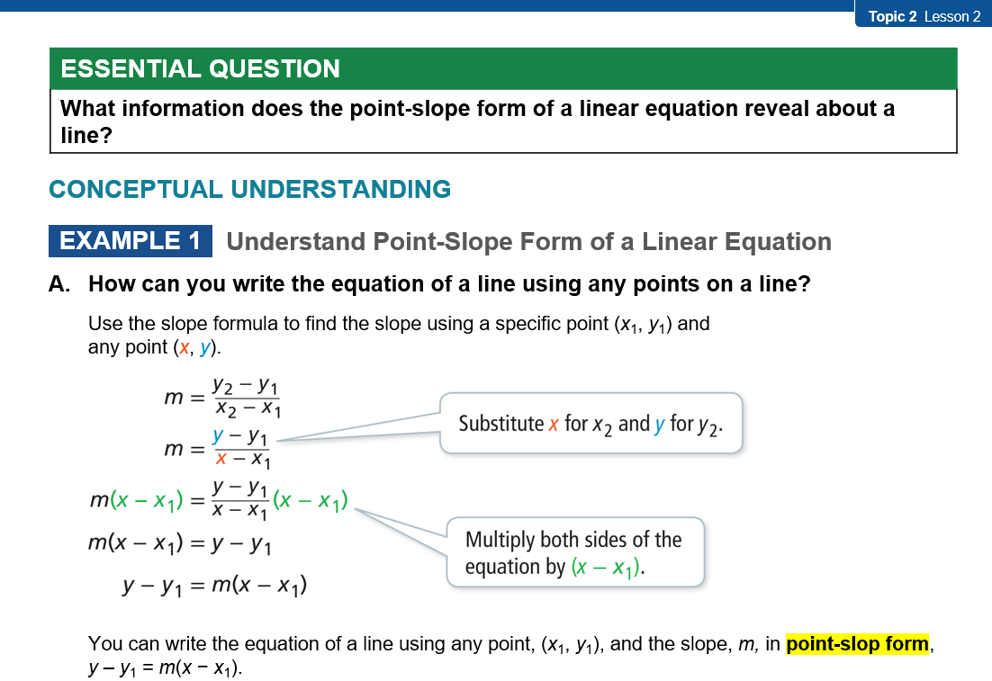  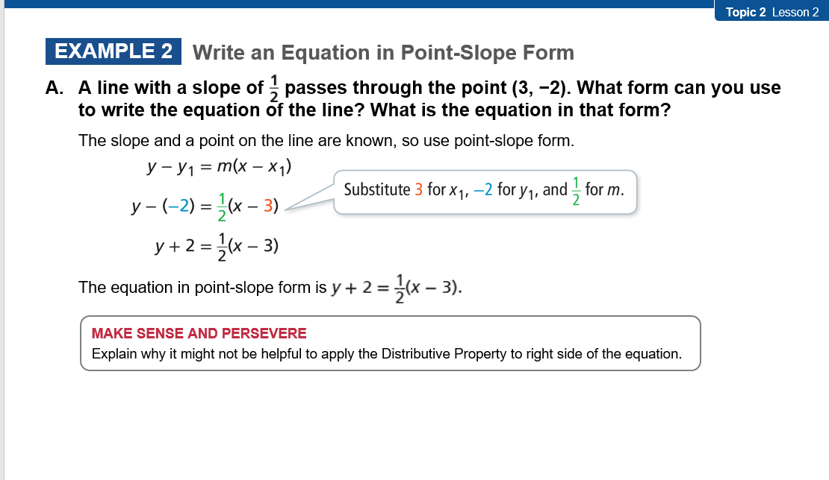  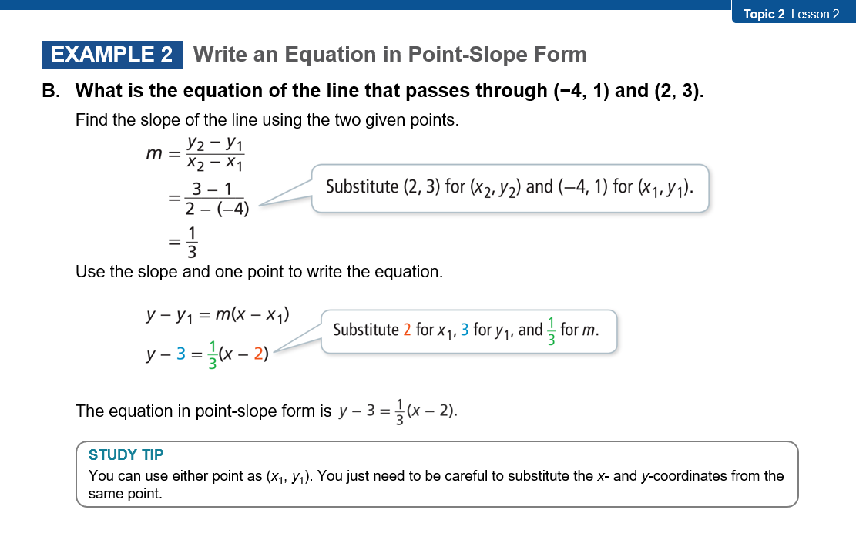  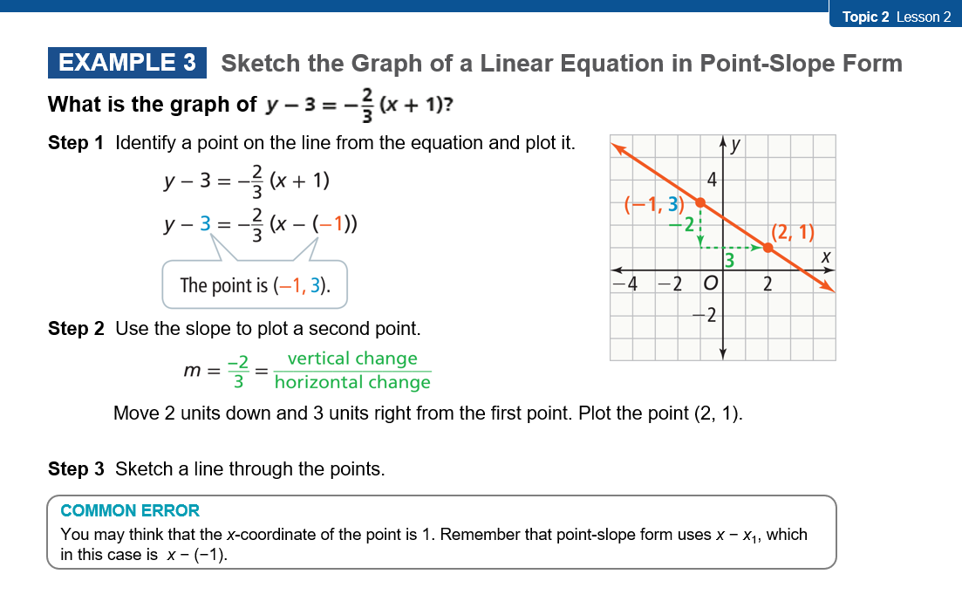  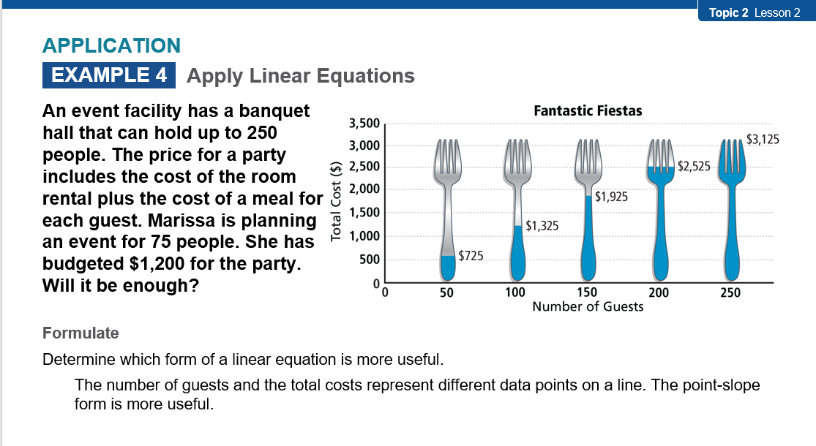  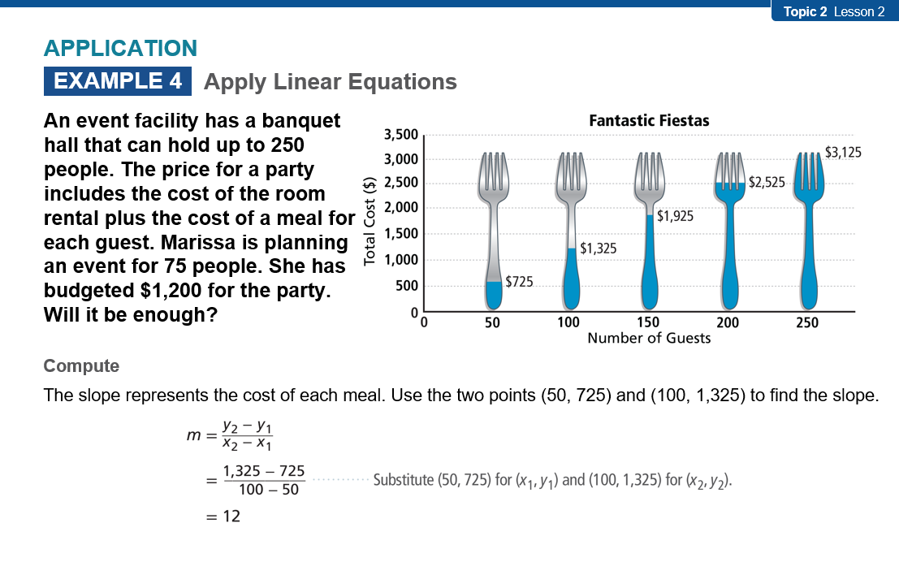  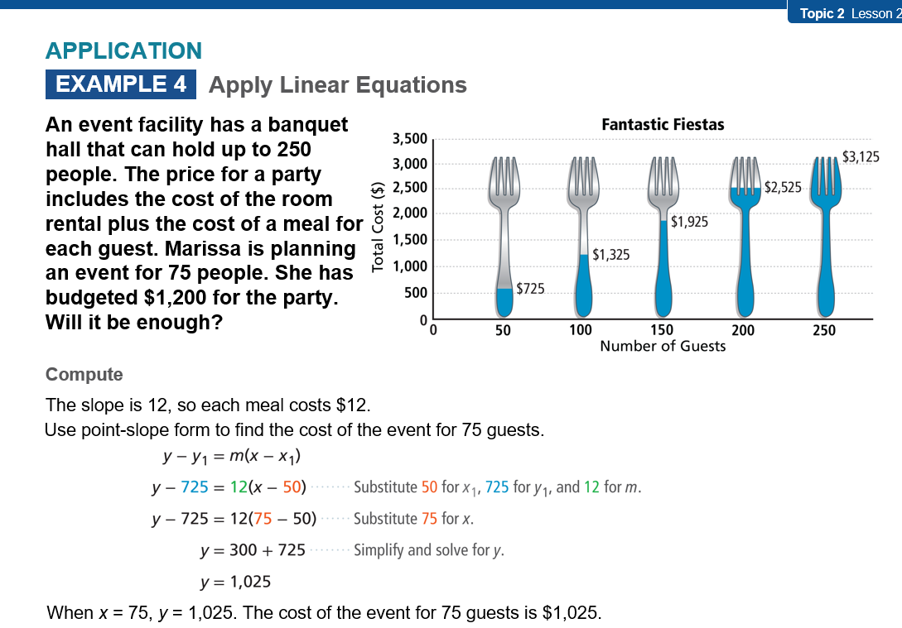  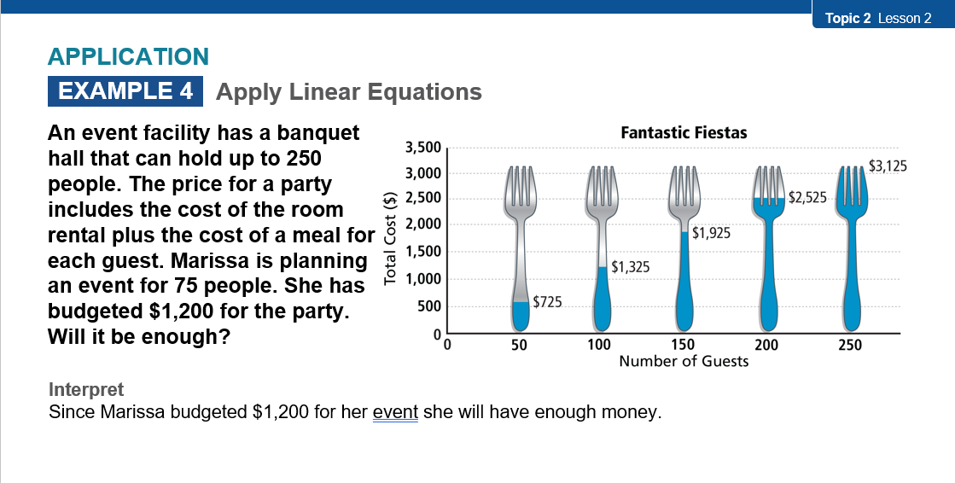  - Step 3: Practice & Problem Solving: MathXL and Adaptive Practice  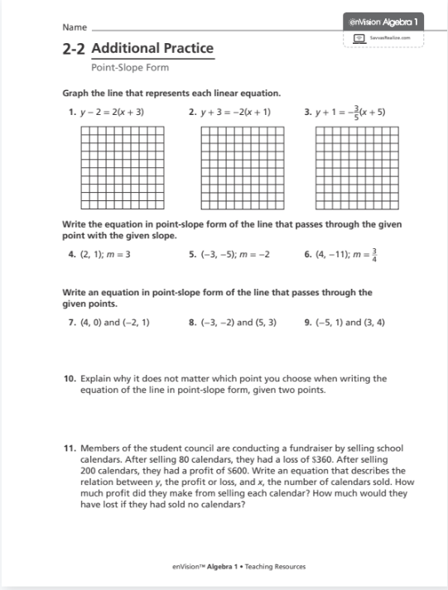  - Step 4: Assess & Differentiate: Lesson Quiz, MathXL, Resource  - PDFs, and Virtual Nerd Video(s)  - Tennessee Standards Practice Workbook  For technology integration resources and suggestions, please click here.
7 | What manipulatives might be integrated into the lesson? What did you learn from using the manipulatives in advance of using them in class with students? | Reference: Interactive Manipulatives  Didax Virtual Manipulatives | Reference: Interactive Manipulatives  - Didax Virtual Manipulatives
8 | What graphic organizer(s) might support students’ conceptual understanding of the process outlined by the performance-based objective(s)? | Reference:  - Graphic Organizer Templates  - Google Drawing Graphic Organizers  - Teacher Vision | Reference:  - Graphic Organizer Templates  - Google Drawing Graphic Organizers  - Teacher Vision

